Name Nuzhat Qureshi
Roll No BIT-24S-029
Github link https://github.com/NuzhatQureshi90/Pythons-lab-manual-IT-A-/upload/main

LAB MANUAL # 01
TASK 01
Q-1 Make 2-2 programs of each datatype.
- NUMERIC TYPES:
- Integer:
Program:
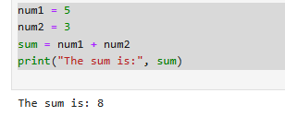
Program:
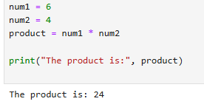

- Float:
Program:
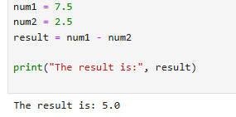

Program:
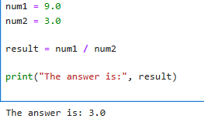
- Complex:
Program:
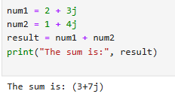
Program:
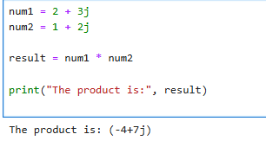
- SEQUENCE TYPES:

- String

Program:

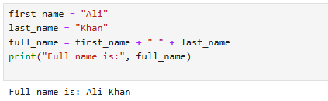

Program:

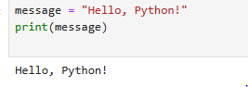

- List:

Program:

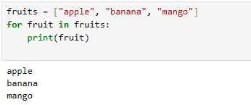

Program:

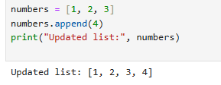

- Tuple:

Program:

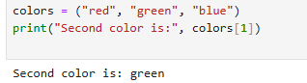

Program:

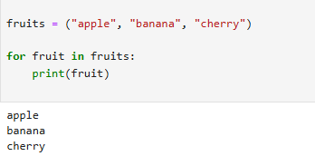
- Range:

Program:

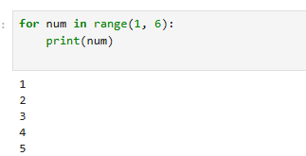

Program:

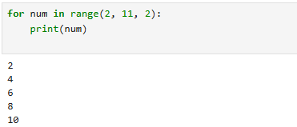

- SET TYPES:

Program:

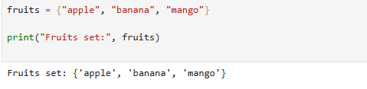

Program:

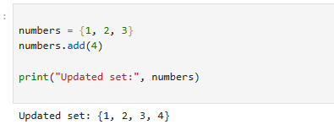

- Frozen set:

Program:

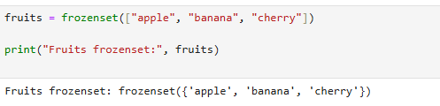

Program:

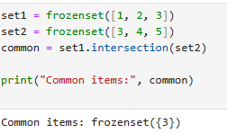

MAPPING TYPE:

- Dictionary dict:

Program:

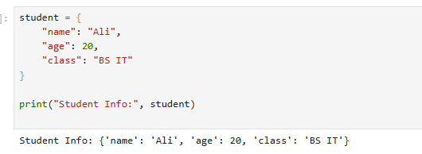

Program:

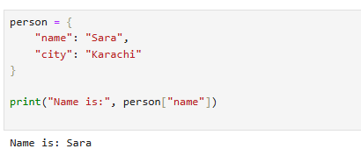
BOLEAN TYPE:

Program:

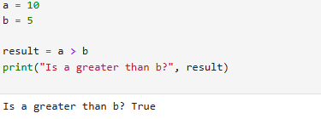
Program:

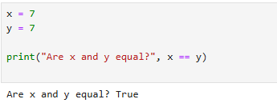

TASK NO 02:

Q.2 Make up to 5 shapes programs using *

Programs:
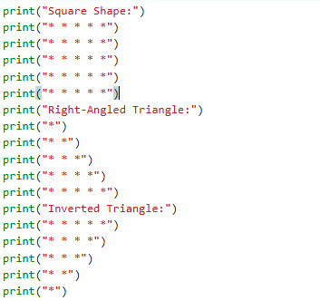

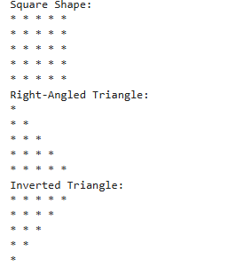

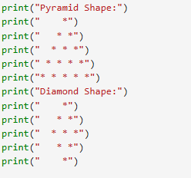

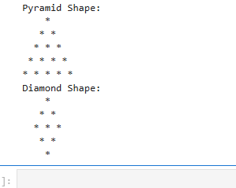

TASK 03

Q.3 Make same shapes you have made in task 2,using * multiple by number.

Program:
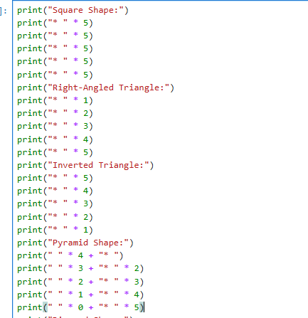

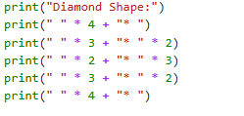

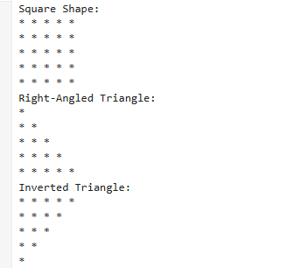

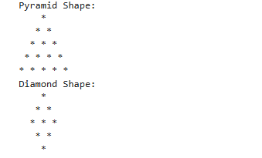

LAB MANUAL 2:

TASK 1:

Q.1 Print numbers from 1 to 10 using a for loop.

Program:

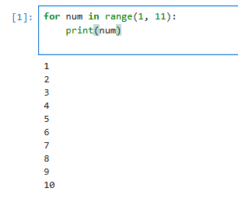

Task 2:

Q.2. Print all even numbers between 1 and 20 using a while loop.

Program:

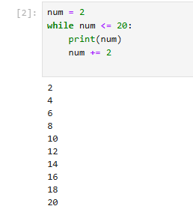
TASK 3:

Q.1. Calculate the sum of numbers from 1 to 100 using a loop.

Program:

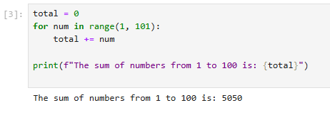
TASK 4:

Q.1. Print the multiplication table of 5 using a loop.
Program:

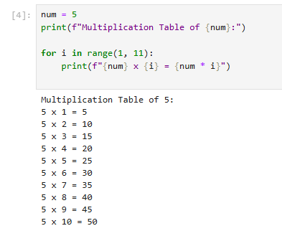
TASK 5:

Q.1. Find the factorial of a given number using a for loop.

Program:
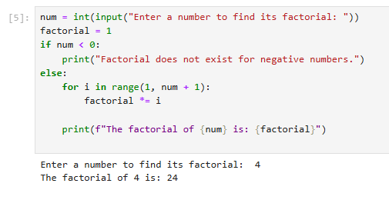

TASK 6:

Q.1. Create a list of numbers and print only the odd numbers using a loop.

Program:

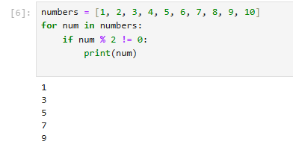
TASK 7:

Q.1. Iterate over a list of fruits and print each item.

Program:

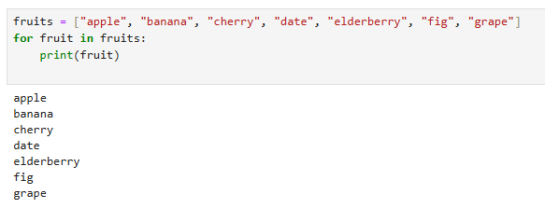

LAB MANUAL #04

TASK 01

Q.1. Write a python program to take 2 numbers as input and perform all arithmetic operations on them.

Program:

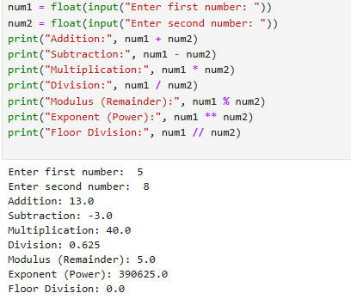

TASK 02

Q.1. Create a function that takes two numbers and return their sum, difference, product, and quotient.

Program:
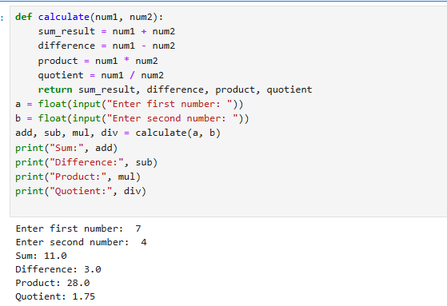

TASK 03

Q.1. Write a python script to find the remainder when one number is divided by another.

Program:

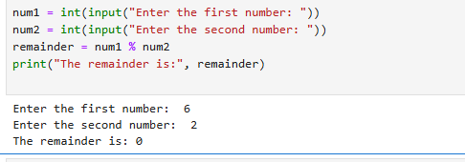

TASK 04

Q.1. Write a program to calculate the area of a circle using the formula: area=pi*r^2.

Program:

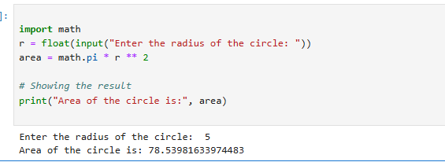

Task 05:

Q.1. Implement a program that takes a number as input and returns its square and cube using exponentiation.

Program:

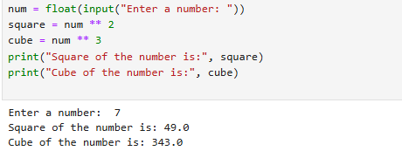

TASK 06:

Q.1. Create a simple calculator in python that allows the user to choose an operation (addition, subtraction, etc) and inputs two numbers.

Program:

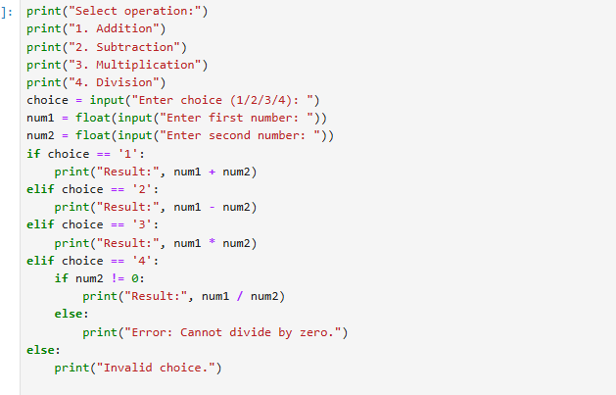

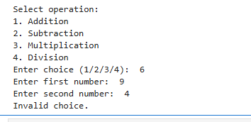

LAB MANUAL 6:
TASK 1:

Q.1. Basic Task: Write a program that checks if a given number is positive, negative, or zero.

Program:

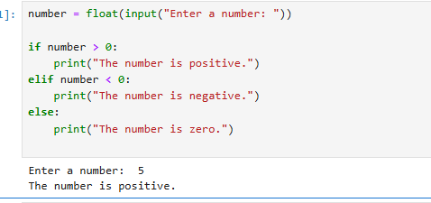

TASK 2:

Q.1. Intermediate Task: Write a program that takes user input and determines whether it's a even or odd.

Program:

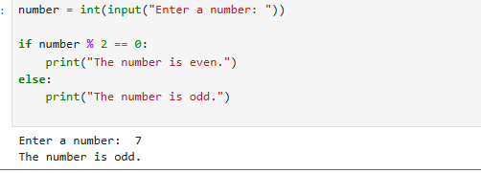

TASK 3:

Advanced Task: Create a program that asks user to print:
"Excellent" if marks are above 80
"Good" if marks are between 60 and 80
"Needs Improvement" if marks are below 60

Program:

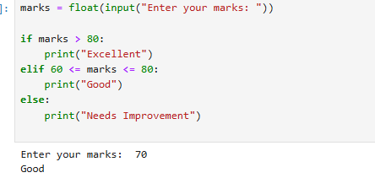

LAB MANAUL 5:
TASK 1:

Q.1. Basic Task: Write a for loop to print the first 10 natural numbers.

Program:

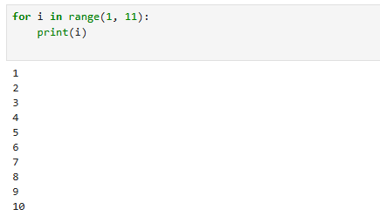

TASK 2:

Q.1. Intermediate Task: Write a while loop that prints numbers from 10 down to 1

Program:

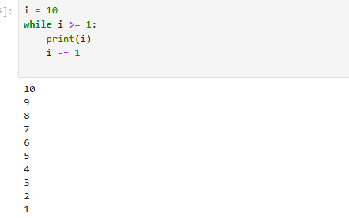

TASK 3:

Q.1. Advanced Task: Create a program that uses a for loop to iterate over a string and count the number of vowels.

Program:

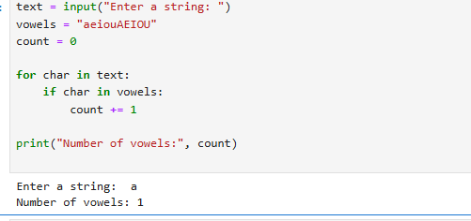

TASK4:

Q.1. Write a program that prints the Fibonacci series up to n terms using a while loop.

Program:

